Task-7 Angular

**🚀What is Angular?**

Angular is a frontend framework used for building Single Page Applications (SPAs) 🧩.

It is a web application programming language based on TypeScript 📘.

🔹 **Angular CLI Commands (Common):**

* ng new project-name # Create new Angular project
* ng serve # Run development server
* ng generate component name # Create new component
* ng build # Build project for production
* ng test # Run unit tests

**📦 Key Files and Folders**:

* **package.json** 📄 – Manages project dependencies 📚 and scripts 📜.
* **angular.json** 🛠 – Angular CLI configuration file (build options, project settings).
* **src/** 🗂 – Source folder containing:
* **app/** 📂 – Main application code (components, services).
* **assets/** 🖼 – Static resources like images, stylesheets, etc.

**⚙ .NET Comparison:**

* In .NET, packages are in a solution file 🧾.
* Angular uses package.json to manage application dependencies 🔗.

**💻 Development & Build Tools:**

🧑‍💻 Code Development:

* Developers write code using VS Code 🧠💻.

Tools:

* .NET → MSBuild 🏗
* Angular → Angular CLI (Command Line Interface) 📟

**🧪 Angular CLI Commands:**

npm install -g @angular/cli ➕📦 – Install Angular CLI globally.

ng version 🔍 – Check Angular and Node versions.

ng build 🛠 – Build the Angular project.

ng serve 🚀 – Start development server with live reload.

**📥 Dependency Management:**

**📌 Using npm :**

npm is used to install dependencies listed in package.json 📋.

Creates a node_modules/ folder 🗃 behind the scenes, containing all packages📦.

**🔒 package-lock.json :**

Ensures all developers use the same versions 🧩.

Prevents errors caused by version mismatches ⚠.

🎨 **Assets & Build Output:**

HTML, CSS, favicon, and static files are stored in assets/ 🎨.

On build, everything is compiled into dist/ 📦.

Similar to .NET’s output in the bin/ folder 📁.

**📦 NuGet vs npm :**

🧰 NuGet – Used in .NET for package management.

🛍 npm – Used in Angular to manage node packages.

**🚀 Step-by-Step:** Clone & Build Angular Project Using Angular CLI

**✅ Prerequisites:**

Make sure the following are installed on your system:

* Node.js (<https://nodejs.org/>)
* Angular CLI (npm install -g @angular/cli)
* Git (<https://git-scm.com/>)

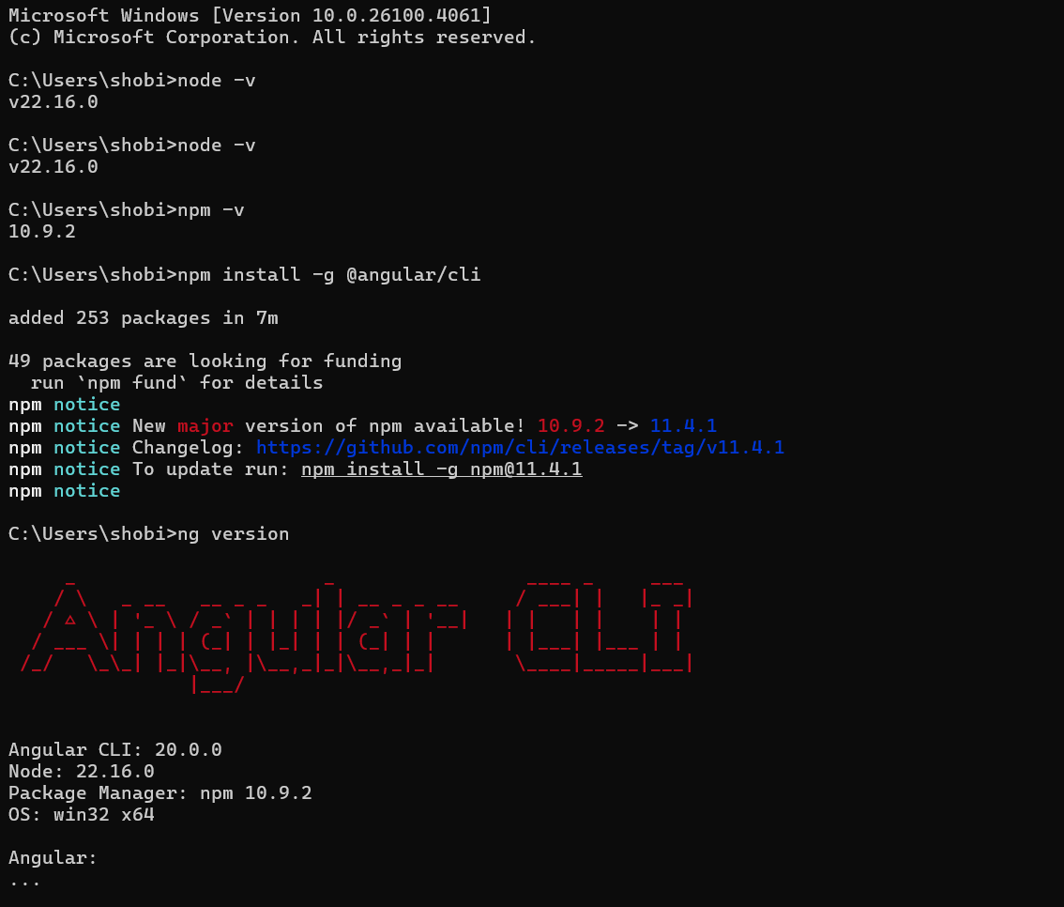

**📥 Clone the Angular Project from GitHub:**

* Open a terminal and run:



* Then move into the project directory:



**2. 📦 Install Project Dependencies:**

After cloning, install the required packages using npm:

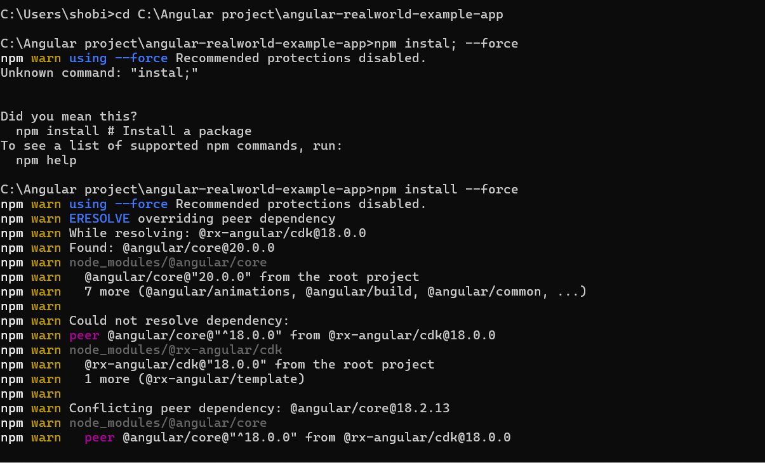

**3. 🏗️ Build the Project:**

For Angular 12+ you can also use**:**



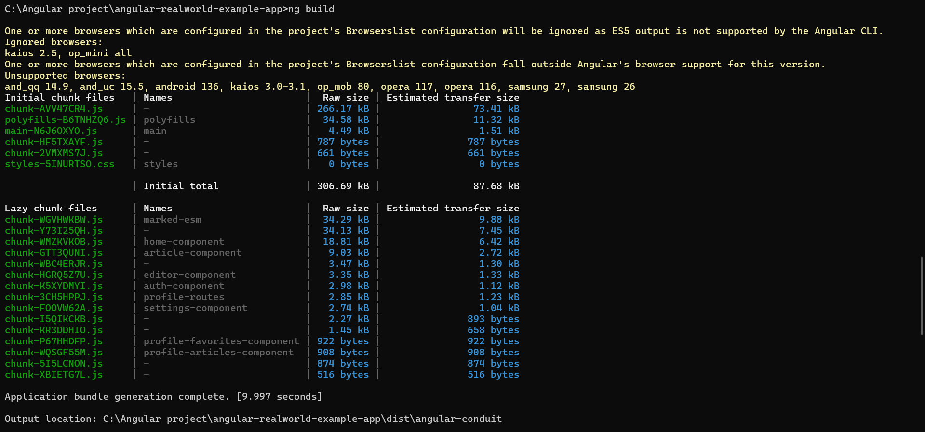

**4. 🧪 Test the App Locally (Optional)**

You can test it by serving it locally:

* ng **serve**

Then open a browser at:

👉 <http://localhost:4200>

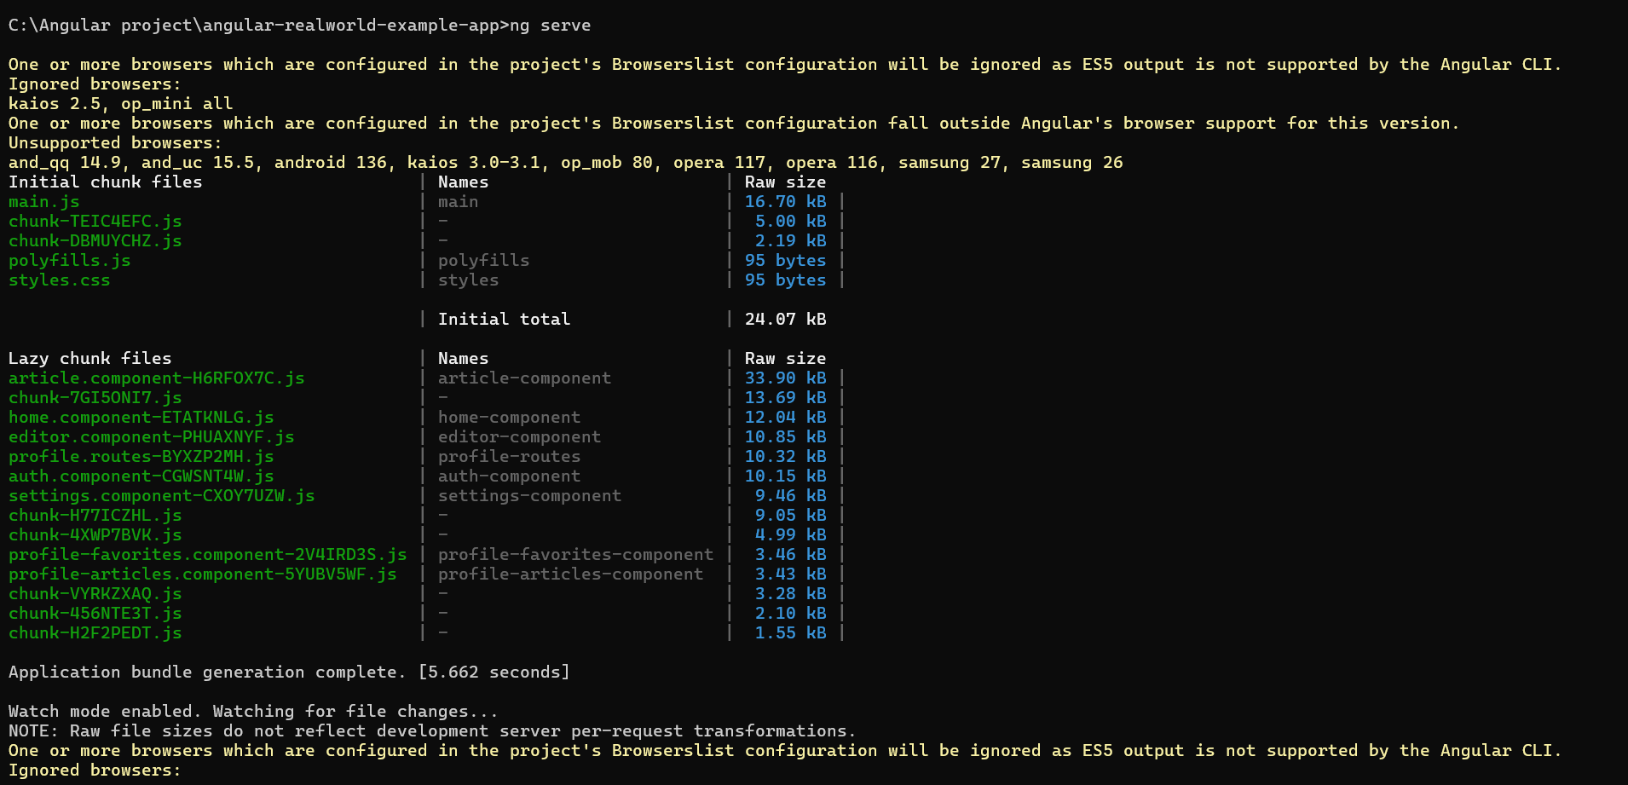

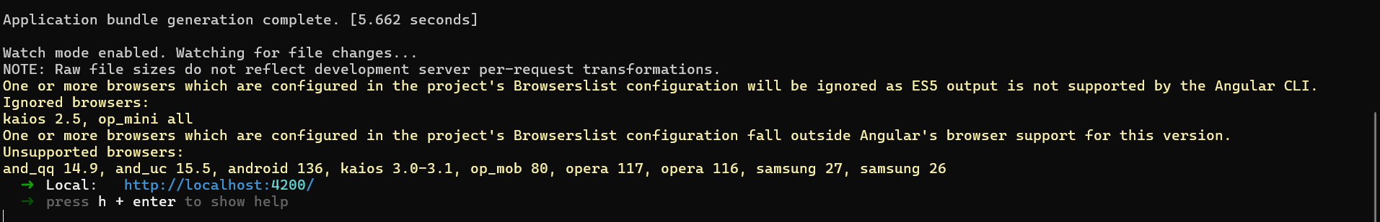

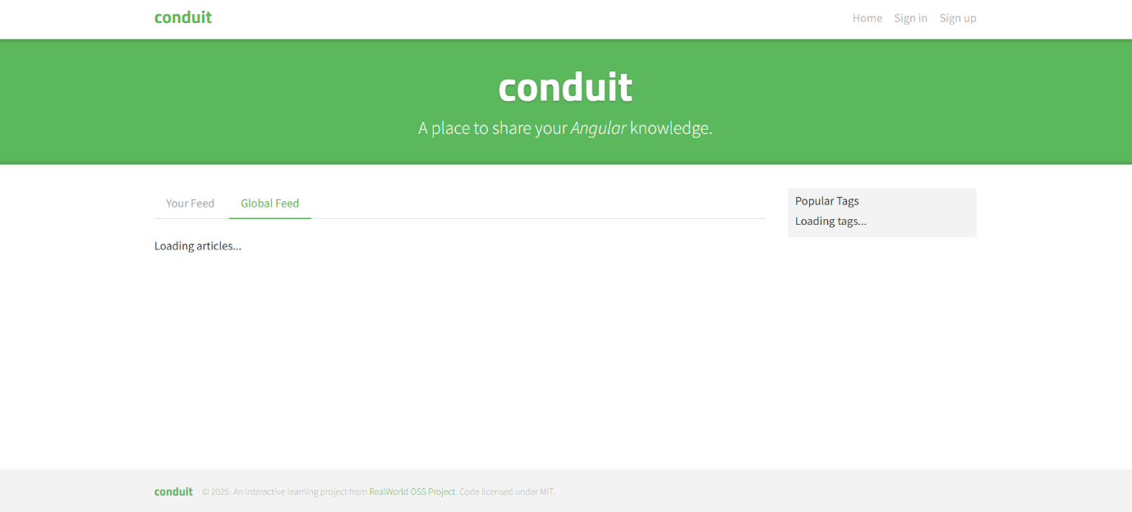

**5. 🌐 Deploy :**Once the project is built, you can deploy the contents of the dist/your-angular-project/ folder to:

* GitHub Pages
* Firebase
* Netlify
* Vercel
* Your own server (Apache, Nginx, etc.)

**🔹 Core Features**

* Component-based architecture
* Two-way data binding
* Dependency injection
* Routing and navigation
* RxJS for reactive programming
* Ahead-of-Time (AOT) compilation
* CLI (Command Line Interface) for scaffolding and management.